Procedure Information
Line of Business / Department  Consumer Lending/Dealer Financial Services |  | Subject  Goldmine Record Management
Distribution  DFS Goldmine Administrators/Operations Support | Version  1_PUB |  | Procedure Number |  | Effective Date  07/23/12
Issued By  Dealer Financial Services |  |  | Type  Procedure | Level  Standard | Last Review  10/14/11
Approvals  Jim Smith |  |  |  |  | Next Review  07/23/13

Printed copies are for reference only. Please refer to the electronic copy for the latest version.

In this document
This document contains the following topics:

Procedure Information 1
In this document 1
1. Scope 2
2. Roles and Responsibilities 2
3. Prerequisites 2
4. Applicable Policies 2
5. Applicable Systems 2
6. Process Flow 2
7. Glossary 2
8. Procedures 3
8.1. Documentation Gathering 3
8.2. Update Goldmine Database 3
9. Key Performance and Key Risk Indicators (KPI & KRI) 14
10. Controls 14
11. References and Related Documents 15
12. Points of Contact 16
13. Appendix 16
14. Change Log 16

Scope
Goldmine contains the client database for Dealer Financial Services. It is used to maintain a record of Dealer contacts and enables Blast Fax, a way to automatically fax information or requests to dealers automatically.
Goldmine is periodically updated to reflect new Dealer contact information and to delete outdated information.
Generally, the level of detail captured herein is intended to provide an experienced
Teammate with an overview and understanding of the subject process and underlying activities and should serve as a resource to such individuals.

Roles and Responsibilities
Role | Responsibility
DFS Business Project Manager | Facilitates process to update Goldmine.
Operations Specialist | Provides Dealer contact information.

Prerequisites
Access to Goldmine

Applicable Policies
There are no Applicable Policies associated with this procedure.

Applicable Systems
System | Definition
Goldmine | Dealer contact database

Process Flow
There is no process flow associated with this procedure.

Glossary
There is not a glossary associated with this procedure.

Procedures

Documentation Gathering

Goldmine is updated whenever the Business Project Manager receives an email from the Operations support group regarding contact information for a new or existing Dealer or to deactivate/reactivate a Dealer.

Step 1 – Send notification by email
Operations Specialist

Send email to Business Project Manager to provide contact information for an existing or new Dealer or to deactivate/reactivate a Dealer.

Step 2 – Receive Goldmine Request
Business Project Manager
Retrieve email with Goldmine request.

Update Goldmine Database

Step 1 – Open Goldmine and Login
Business Project Manager
Note: If Goldmine shortcut is saved on PC desktop, click on the shortcut and skip 1.

Type into Internet Explorer address bar (Figure 1):

http://igoldmine.suntrust.com/igoldmine/
Press ENTER

Figure 1

- Click on Microsoft ActiveX Control: Loose Windows (Figure 2).

Figure 2

Log in (Figure 3):

User name: RACFID

Password: same as Novell password
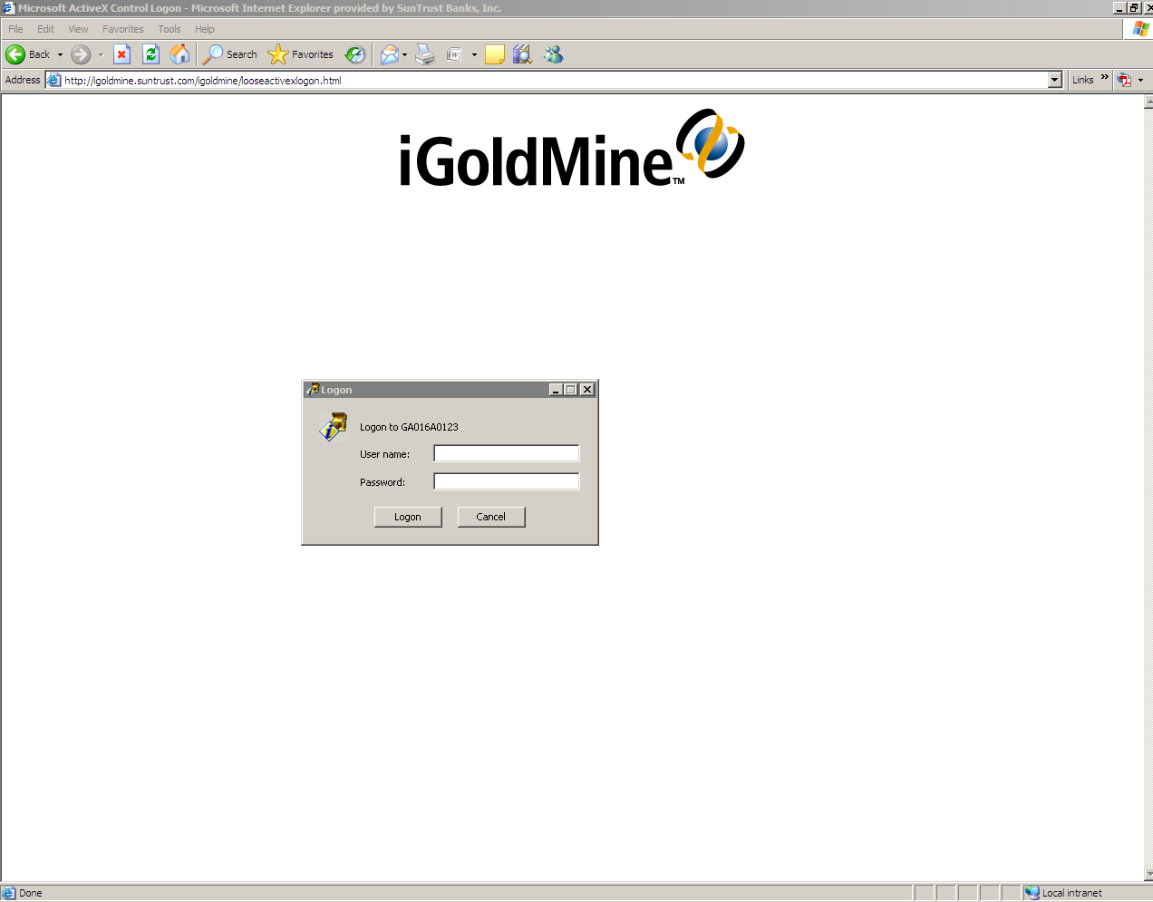
Figure 3

- Double-click on Goldmine icon (Figure 4).
Figure 4

- Log into Goldmine using assigned Goldmine Username provided by Goldmine administrator. Leave password field blank and click OK (Figure 5).
Note: Goldmine Username is not same as RACFID.
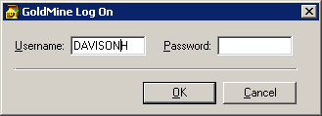
Figure 5

Step 3 – Login as administrator
Business Project Manager
- Click File and click Log in Another User (Figure 6).

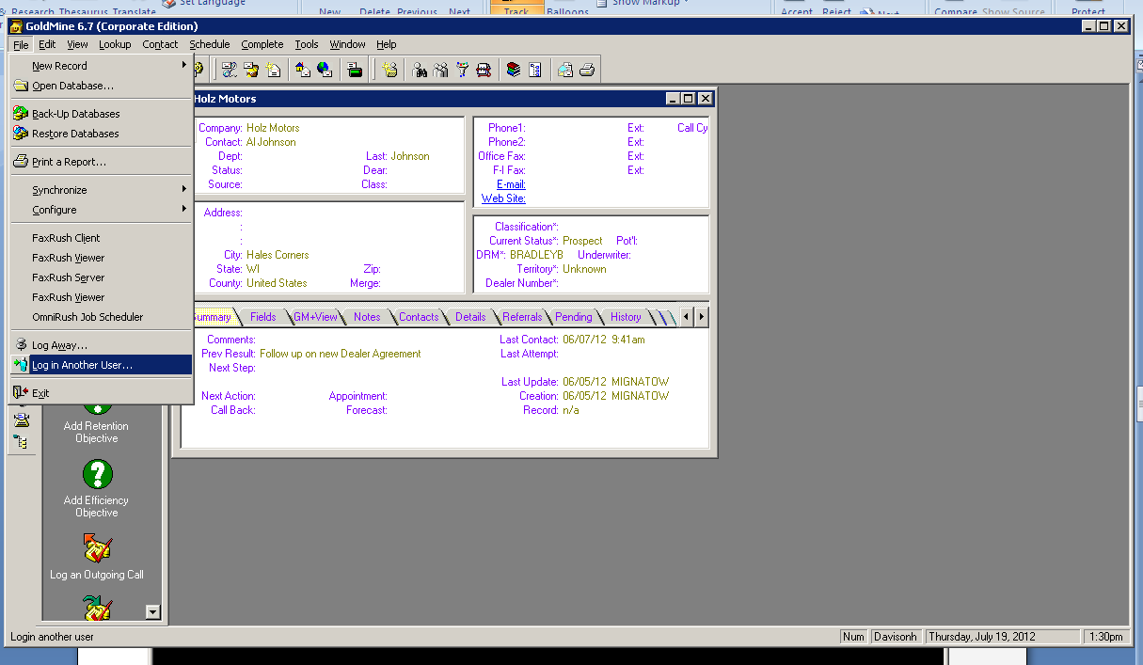
Figure 6

- Type bruinfax as the username; leave password field blank and click OK (Figure 7).

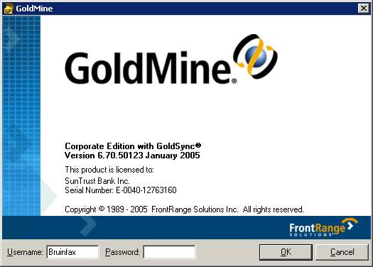
Figure 7

Step 4 – Add Contact

Note: If updating existing Dealer information, skip 8-9 and reference 10.a. below.
Note: If only changing status, skip 9-10 below and proceed to Step 5.
Business Project Manager
- Click File; New Record; New Company and Contact (Figure 8).

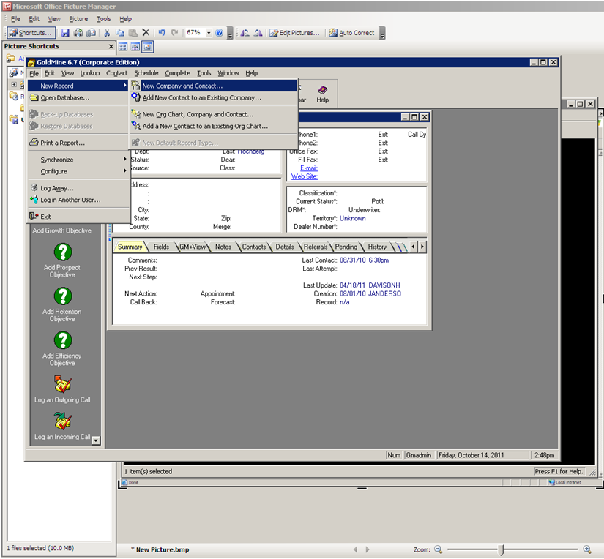
Figure 8

- Enter the appropriate Company, Contact, and Phone Number information provided in the email from Operations Specialist and click OK (Figure 9). This initiates a search for duplicate entries in the system.

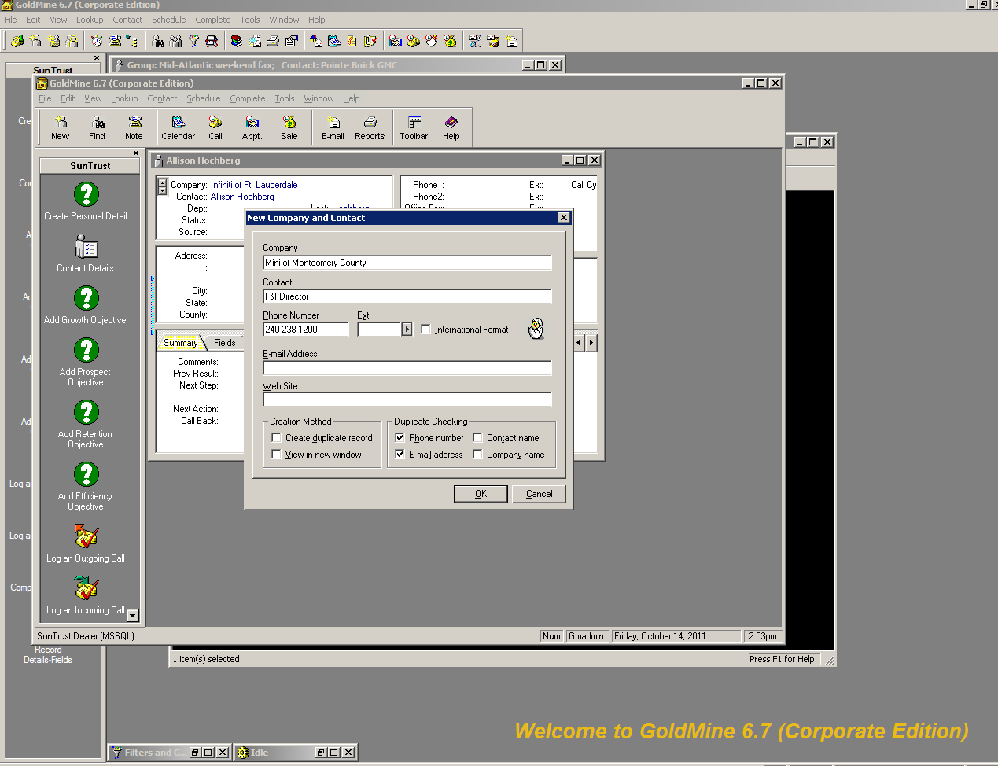
Figure 9

- Click on each field (Figure 10) as appropriate to:
  - type information provided by Operations Specialist into Contact record
  - set Classification field to Auto Dealer and Current Status field to Active
  - change territory to appropriate DRM (see 11. References and Related Documents).

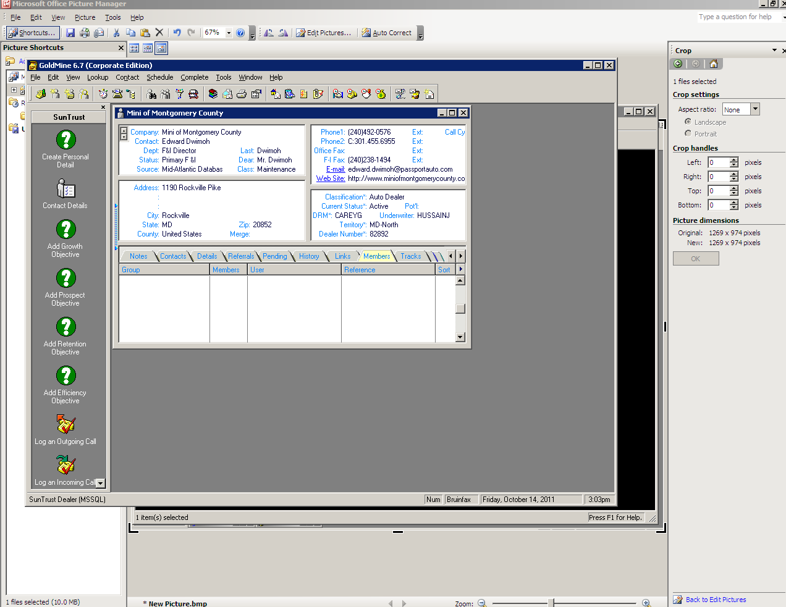
Figure 10

Step 5 – Update Contact Status

Note: If not changing status, skip this step.
Business Project Manager
- Change Current Status field to reflect Operations Specialist email regarding status (Figure 11).

Figure 11

Step 6 – Add as Member to Fax Groups

Note: If deactivating or updating Dealer, skip this step.
Business Project Manager
- Right-click Members tab on the selected Contact Record and click New (Figure 12).
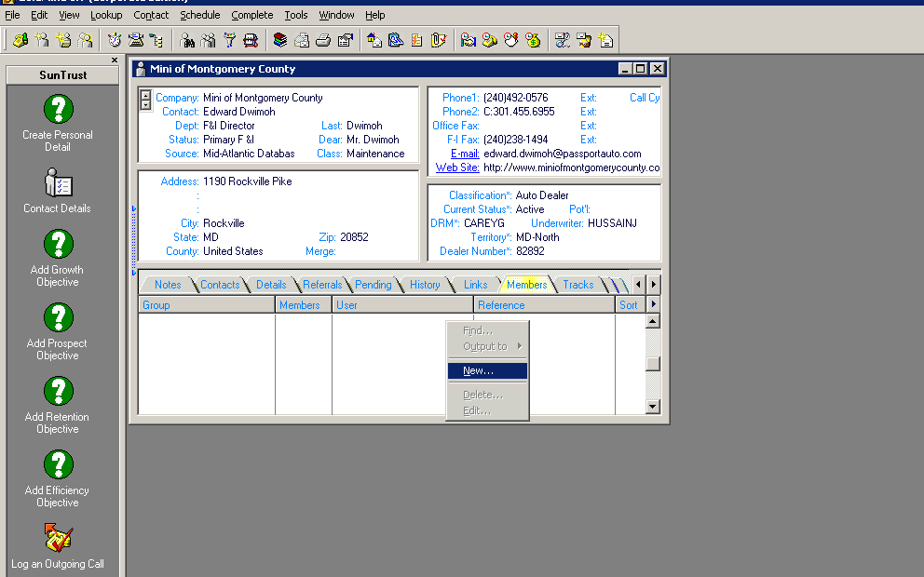
Figure 12
- Add to groups based on grid link (See 11. References and Related Documents) (Figure 13). Repeat for additional groups that need to be added.
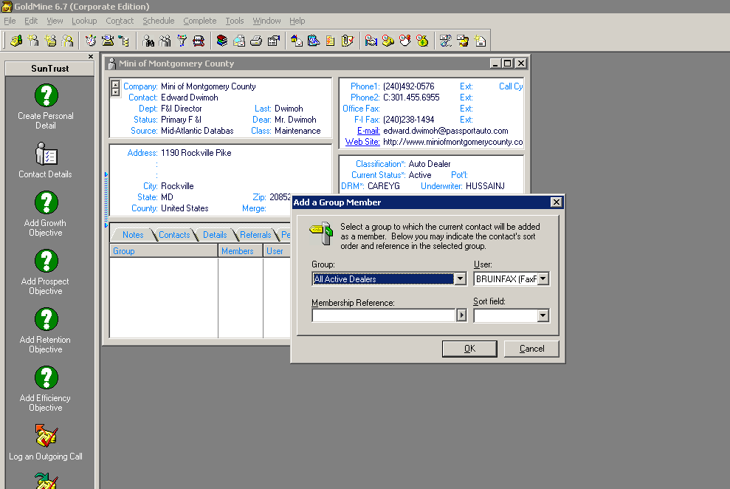
Figure 13

Step 6 – Delete as Member of Fax Groups

Note: If reactivating, updating or adding Dealer, skip this step.
Business Project Manager
- Right-click on Members tab on the selected Contact Record selected and click Delete (Figure 14). Repeat for all Groups in which the contact is a member.

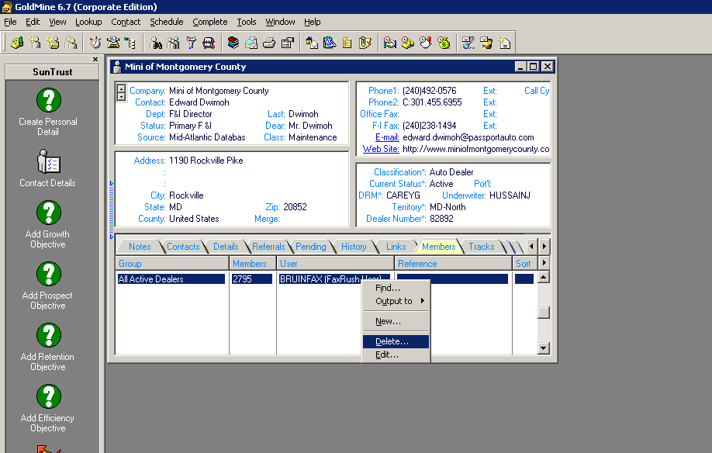

b. Repeat for all Groups that the Contact is a member of.

Key Performance and Key Risk Indicators (KPI & KRI)
There are no Key Performance or Key Risk Indicators for this procedure.

Controls
Please contact your Operational Risk Officer for details

References and Related Documents

DRM Territory Grid
DRM | Territory
BBUTTO | CO-Colorado, TX-Texas
AINSG | MD-South, MD-DE
BRADLEYB | Wisconsin
CAREYG | MD-North
CDUDLEY | TX-Texas
FSZ-Bob Zimmerman | PA-FSZ, NJ-New Jersey
FSZ-Jim Fox | PA-FSZ, NJ-New Jersey
FSZ-Steve Schymanski | PA-FSZ, NJ-New Jersey
HBITTMAN | KY, GA-Alabama, TN-Nashville, GA-Rome, GA-Atlanta
JANDERSON | FL-South, FL-Miami
JGUNTHER | GA-Alabama, FL-Alabama
NC West | NC-West, MA-South Carolina
JONESC | GA-Atlanta, GA-Rome, TN-Nashville, IL-Illinois
ROWENS | FL-Central, FL-Southwest, FL-Miami, FL-East Central, FL-North Central, FL-Northeast, FL-West Central
SMITHG | VA-North
STANDLEY | NC-East
VANSYOC | Wisconsin
WHITLEYK | VA-Central, VA-West, VA-East
WILLIAMS | GA-Atlanta, GA-Macon, GA-South Carolina, GA-Augusta, GA-Brunswick, GA-Savannah, GA-Columbus, KY-Kentucky
WRAO | FL-Tampa, FL-Miami, FL-West Central, FL-Southwest, FL-South
ZIMMERMA | MN-Minnesota, ND-North Dakota

Points of Contact
For questions about this procedure, contact:

John Somebody, DFS Business Project Manager-Dealer Financial Services, 804.xxx.xxxx, email address

Appendix
There is no appendix associated with this procedure.

Change Log
Version | Section | Change Author | Date | Change Summary
1 | All | John Somebody | 7/23/12 | Converted procedure to new template

